Storyboard

# Definition

A storyboard is a sequence of sketches or screen layouts. Usually, it is a translation from a written scenario into a visual illustration. In a storyboard, it is showed how users would interact with an application or interface when undertaking a specific task and how the system functions would react. The level of details varies depending on the development stage of the lifecycle: the more it is advanced, the more details are represented.

# Benefits

* Provides an overview of the system and allows to organize ideas to designers
* Allow means of communication between users, stakeholders and designers
* Demonstrates the functionality of the system and navigation scheme
* Can evaluate design ideas and alternatives
* Can be evaluated by users to obtain early feedback
* It is cheap
* Allows rapid and iterative development

Disadvantages

* checking errors in storyboards is limited
* it may be harder for programmers to code as the storyboard is not so detailed
* paper UI could be less convincing

# Best practices

## Method

* Use [scenarios](http://www.usabilitynet.org/tools/scenarios.htm) as input.
* [Brainstorm](http://www.usabilitynet.org/tools/brainstorming.htm) ideas, this may include lists, charts, doodles, and quick notes
* Select the best ideas: re-consider the project requirements, time and resource constraints, the target audience and end users. Select the top ideas and try to get feedback from others involved.
* Sketch each screen and describe any pictures, images, animations, sound, music, video or text.

# Examples

http://msdn.microsoft.com/en-us/library/windows/desktop/ff800706.aspx

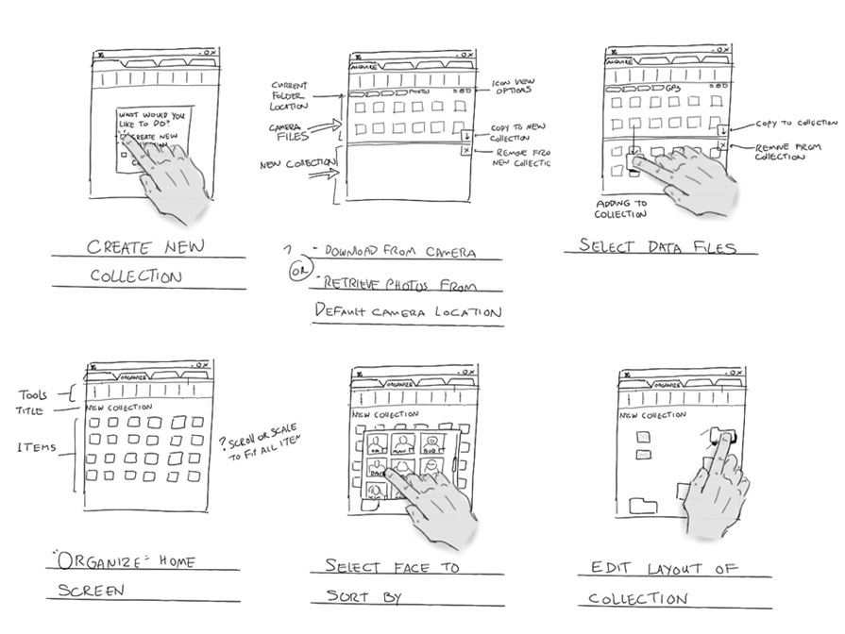

Figure 2 Storyboard showing the creation of a new collection of items

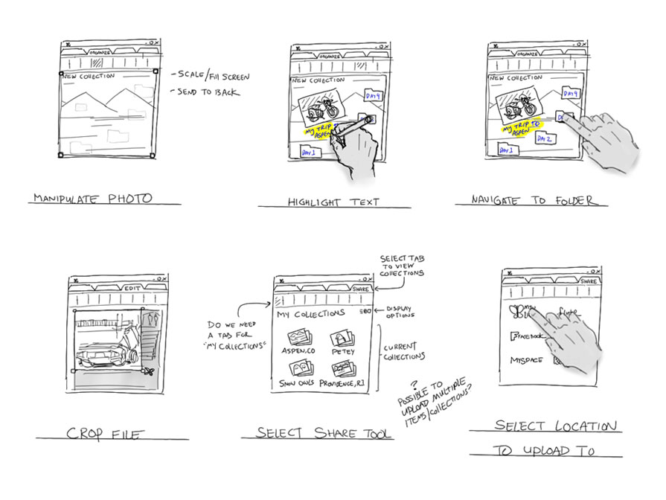

Storyboard showing the actions to edit an item

http://uxmag.com/articles/book-excerpt-the-user-experience-team-of-one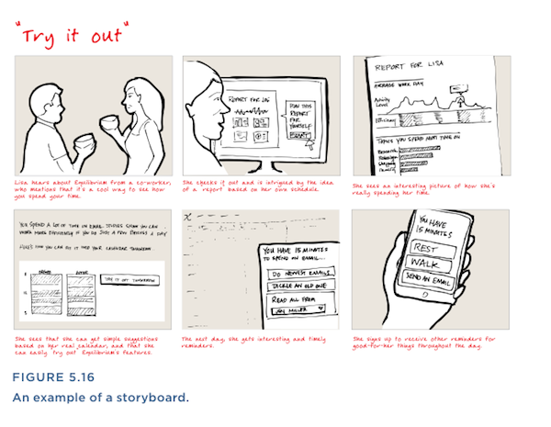

Sources

<http://www.usability.gov/what-and-why/glossary/storyboard.html>

<http://www.usabilitynet.org/tools/storyboarding.htm>

<http://www.interaction-design.org/encyclopedia/contextual_design.html>

libro p. 118-119